**R C Patel Arts,Commrce and Science College Shirpur**

**Department of botany**

**Report On Academic Achievement**

**2024-25**

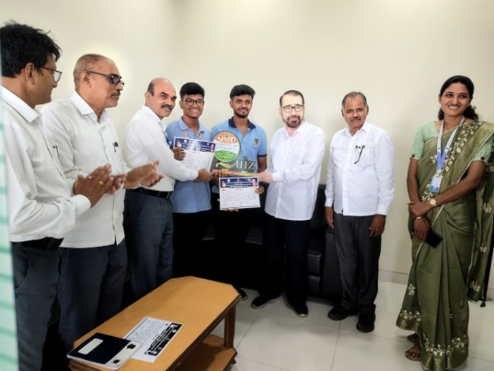 A state level quiz competition was organized by Pratap Autonomous College, Amalner on 5th and 6th September 2024.Students participated from many colleges, from R C Patel Arts and Science College Gaurav Vinay Khairnar (M.Sc. Botany) and Jayvardhan Rajendra Marathe (M.Sc. CS) were also participated in this quiz competition, with the hard work and presence of mind they won the second prize money and trophy, and make feel proud to entire RC Patel family

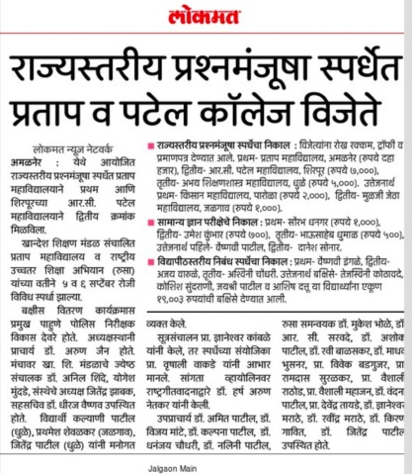 Principal sir felicitated both students and wishes for their bright future.

